MSU Meeting Agenda: November 1st, 2016

- Presentation of minutes from October 11th, 2016
  - Corrections? None

- Report from the MSU Officers
  - President—Nadeem El-Kouri
    - St. Albert’s Day
      - Poster space assignment will be sent electronically, prior to November 2.
      - Bring suitable mounting pins or tacks.
      - You must present your poster during your designated time
      - Posters must be removed following the poster review at 6:00 pm on Thursday, November 3.
    - Student groups need to contact Tomas (and CC me) when exploring new fundraising items
Logo use must be approved
    - Technological additions to the lecture halls
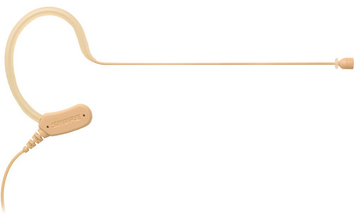
Trying to get faculty to use these new mics that are better than the current ones – so try to remind the lecturers if they are not using them!
Also implementing the use of a wireless mouse during lecture – encourage lecturers to pick them up from Ed Tech (by room 170)
    - M1/M2 Thanksgiving basket competition
      - Collection: Nov 14-16th from 9-4pm
      - Prayer Service: Nov 17th @ 12 in Atrium
Contact PCM Representatives for more information
    - Faculty-Student Holiday Party, Dec 1st 4:30-6:00pm
      - Ugly Sweater Contest
      - Holiday Cookie Contest
      - Faculty are more likely to attend if they receive a personal invitation from you!
Annual party where faculty, student, staff mingle! So personally invite any faculty/staff that you would like to see there to encourage their attendance.

  - Vice-President—Christina Small
    - Fall Semester Activities – thank you to everyone who came out for Adler after dark!
    - Spring Formal Update – still debating between Soldier Field and Museum of Science and industry. Definite March date will be determined hopefully by next meeting

  - Treasurer—Tara Funk
    - Presentation of the Budget
$500 from EMIG will be returned to our budget since they didn’t need it
    - Groups expected to fundraise
    - Reminder to turn in all outstanding budget requests, within two weeks please
    - Tax Exemption
      - Will not reimburse you for spending money on taxes
      - Hand a tax free form to the institution that you are buying from
    - Don’t buy a gift card through a store. If you want to make a gift card purchase, it must go through Tomas and Lakeshore will purchase it and get it to you.
    - Must submit ITEMIZED receipts!! If you leave a tip, then I need both the charge receipt and the itemized receipt.
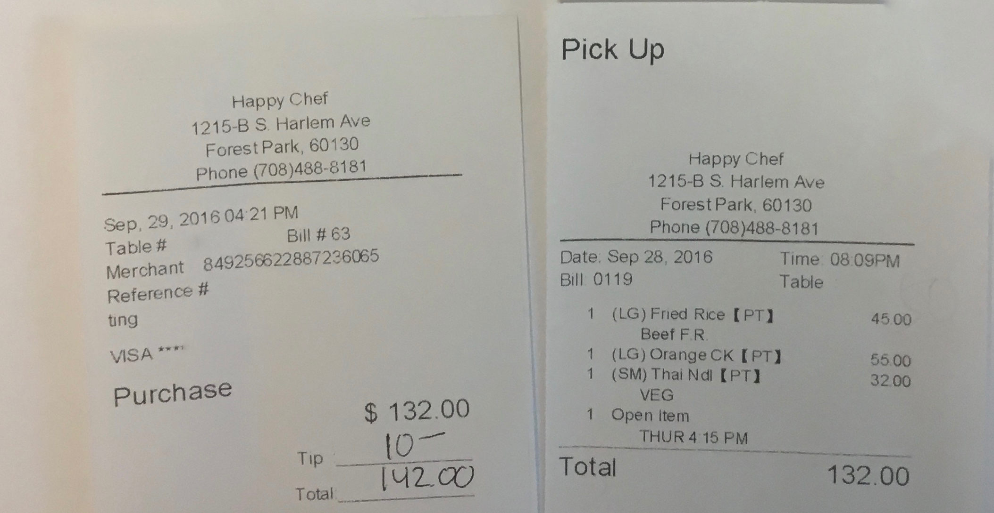

  - Secretary—Priya Patel
None – Happy Diwali !

- Report from Class Presidents
  - M1 – Alyssa Varsanik
Working on fall semi formal Nov 18. (thank you Tomas for all your hard work)
Ticket sales deadline is Friday 11/4 ($5/ticket)
Shadowing M3’s has been going great!
Change of attire to semi formal – no longer 90s themed!
  - M2 – Mitra Mossaddad
Today is the deadline to submit thank you notes for Dr. Brubaker! So please do it ASAP!
Working with Dr. Hopps for UWorld subscription. Expect that around Mid-january – an email will be sent out by end of November to sign up
Doctors in training (STEP1 resource) – check out Mitra’s email regarding this resource and how to sign up
You can start putting up posters for St. Alberts tomorrow
  - M3 – Patrick Kramer
Clerkship Reviews are starting – so they will be reaching out to people
They will be holding another Exam Review for M2 renal block
Christmas ornament sale fundraiser – look out for that email
M1 – make sure you are logging your shadowing with M3 on MyLumen
Anyone that would like to set up a group for thanksgiving basket fundraiser – email Patrick and he will be more than happy to organize groups!
  - M4 – Lizzy Carroll
Graduation speakers – Dr. Pamela Wible (TedMed Speaker)
M4 – fill out Match Day theme survey

- Reports from Stritch or University Committees
  - Medical school dean
  - LCME Site Visit
Happening next Monday/Tuesday – be on the lookout for the reps!
  - CTRE access
    - Quiet study space – still working on access for all students;
    - Thinking about adding portable cubicle set ups for students

- Reports from Student Organizations
  - Movember Fundraiser/Competition – Contact Kenny Joseph with any questions
Fundraiser through Movember organization and proceeds go to cancer research
Please feel free to participate for a great cause!
  - SAS – Anki workshop on Thursday (check your email for details)
  - SNMA – Chili cookoff on Monday (12-1), email will be sent out shortly
Feel free to participate by either cooking your own recipe or eating (or both)
  - SAMSA conference this Saturday (9-2:30), Free admission, feel free to register (loyola wifi doesn’t work so use any other internet source), also feel free to just show up!
  - Physicians for Human Rights – Hunger Week is next week,
Kicking it off with a bake sale this Friday (10-1)! Please donate some baked goods or stop by and support the cause!
Monday – Speaker talking about voter suppression
Tuedsay – Gun violence information

- Reports from OSR Rep – Michelle Peterson and Saad Siddiqui
Nov 11-15 – first conference

- Student Wellness Advisory Group
  - Stritch Friendsgiving - November 15th (6pm) – look out for email for what you would like to sign up to bring for the potluck

- New or Unfinished Business
Update on food services – Starbucks will be replacing Sandellas! YAY
Should be up and running by 2nd week of November
Gym – also adding espresso based coffee next week!!

- Funding Requests
Net Remaining to be requested (for this semester) : $677.80
Total Requested today: $210

  - Women in Medicine: $110 (APPROVED)
    - Dean Brubaker Talk. 11/16/16, 5-6pm. 75 expected to attend. 19 large pizzas (~$140) and 13 bottles of soda ($37) from Damenzo's in Forest Park, plus disposable utensils ($10).
    - “We expect this to be a huge event and have already received ~60 RSVPs from students in addition to 15 faculty and residents. We have already tried calling multiple restaurants in the area and have found the cheapest option to feed the most people. We have also accounted for the ~$83 left from our default $100 from MSU”

  - Polish American Medical Student Society: $100 (APPROVED)
    - Wigilia - Polish Heritage Christmas Eve Celebration. Wednesday 11/30, 6-8PM. 50 expected to attend.
    - Polish Food: Catering (7-8$ per person)
Money is a backup request and will be returned if not all used!

- Room for Improvement:
  - Input? Questions? Comments? Feel free to talk to us or submit your ideas anonymously through the following link:
    - https://goo.gl/forms/oSrghTSVDIOTIGa73

The next meeting will be held on Tuesday, Dec 6th, 2016

Thank you for taking the time to be here tonight!

