MSU Meeting Agenda: December 6th, 2016

- Presentation of minutes from November 1st, 2016
  - Corrections? None

- Report from the MSU Officers
  - President—Nadeem El-Kouri
    - Starbucks is officially open!
      - Hours: M-F 7-10am AND 2-5pm
- suggestion to extend hours during finals
- gym also has a new espresso machine set up
    - Farmer’s Fridge now open
- sign up online for a 50% discount off your first purchase
    - Student groups need to contact Tomas (and CC me) when exploring new fundraising items
    - Group exercise classes
      - Joseph Berg @ jberg@loyolafitness.org
- bring back hip hop, boxing, barre (preferably around 5pm or later)

  - Vice-President—Christina Small
    - Fall Semester Activities – none
    - Spring Formal Update
- Museum of Science and Industry is finalized for March 18.
- we will have reception hour before dinner (open bar)
- there will be access to some of the exhibits
- look out for more info next semester

  - Treasurer—Tara Funk
    - Presentation of the Budget
- there were no requests for this last meeting so remaining funds are rolling over to next semester
    - Groups expected to fundraise
    - Reminder to turn in all outstanding budget requests, within two weeks please
    - Tax Exemption
      - Will not reimburse you for spending money on taxes
      - Hand a tax free form to the institution that you are buying from
    - Don’t buy a gift card through a store. If you want to make a gift card purchase, it must go through Tomas and Lakeshore will purchase it and get it to you.
    - Must submit ITEMIZED receipts!! If you leave a tip, then I need both the charge receipt and the itemized receipt.
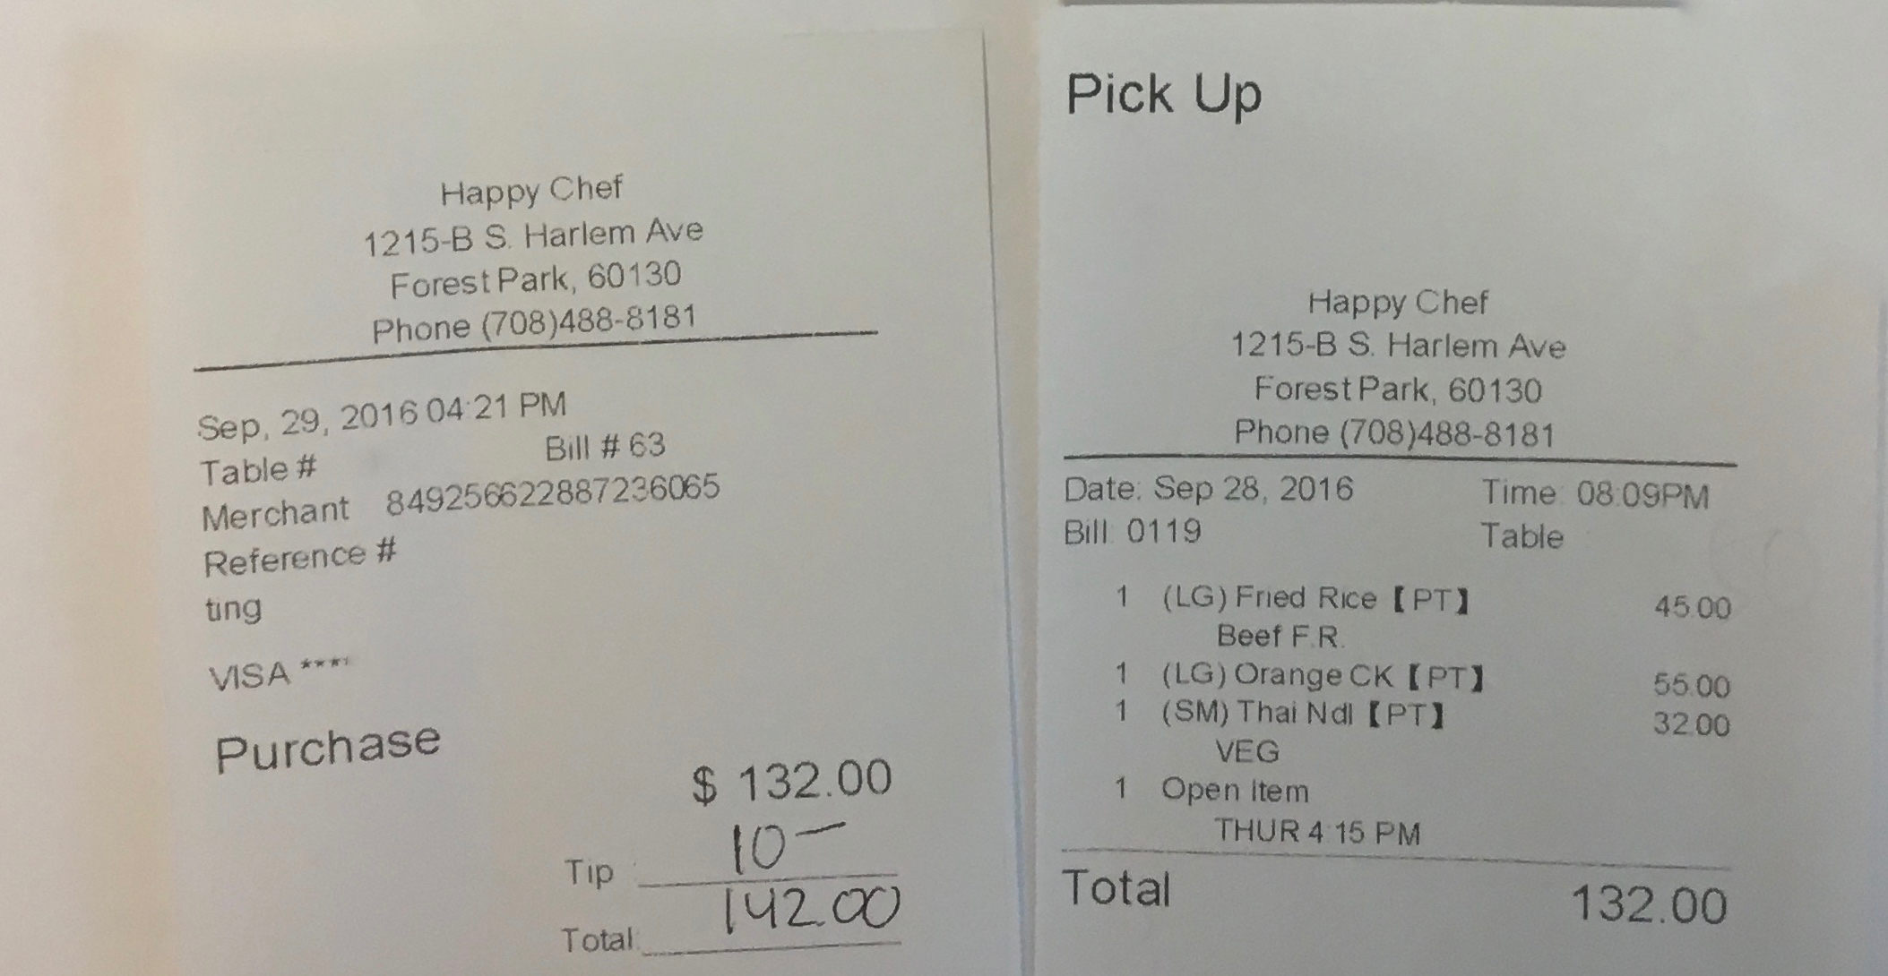

  - Secretary—Priya Patel
None

- Report from Class Presidents
  - M1 – Alyssa Varsanik
Thank you MSU for funds for the fall dance!
  - M2 – Mitra Mossaddad
UWorld sign up will come out after finals – around $300/person (deadline to pay will be after the next loan disbursement)
  - M3 – Patrick Kramer
Ornament sale – check your email
M3’s made a memory book for Dean Brubaker
Condolence cards for Dr. Schreckenberger will be sent out soon– look out for updates in your email
Step 1 panel was a success – email will be coming out with a summary of what they covered, there will be another one next semester too
  - M4 – Lizzy Carroll
Email from Lizzy – “The M4s are right in the middle of interview season, and already counting down the days to match day! For all M4s- PLEASE fill out the survey that Hannah sent out last night about match day. It’s important. Seriously please read your email and fill it out. No other big updates for the M4s- just keep checking your Loyola emails for Match/graduation updates. Good luck on interviews everyone!!! Miss you guys!”

- Reports from Stritch or University Committees
  - Medical School Dean
Finalized by mid/late January
  - Diversity Office Coordinator
Also looking to finalize by mid/late January
  - Quiet study space
Portable cubicle set up – still working on getting these
  - Welcome new Student Life Coordinator - Alia Poulos

- Reports from Student Organizations
SAS – keep using the drive for STEP resources and new additions.

- Reports from OSR Rep – Michelle Peterson and Saad Siddiqui
Went to the conference – working on a pamphlet for incoming students with info about Maywood community and the patient demographics, working on a Ted talk-like seminar with professional speakers, would like to set up a discussion forum regarding current
Michelle – we are in contact with other representatives from other medical schools so if anyone has ideas of things they have seen at other schools and would like to implement at Loyola – just email her or Saad.

- Student Wellness Advisory Group - N/A

- New or Unfinished Business
  - Movember Fundraiser/Competition – Kenny: thanks to everyone who participated and donated. They raised over $180!

- Funding Requests NONE!

- Room for Improvement:
  - Input? Questions? Comments? Feel free to talk to us or submit your ideas anonymously through the following link:
    - https://goo.gl/forms/oSrghTSVDIOTIGa73

The next meeting will be held on Tuesday, Jan , 2016

Thank you for taking the time to be here tonight! Good luck on finals!

