MSU Meeting Agenda: October 11th, 2016

- Presentation of minutes from September 6th, 2016
  - Corrections? No

- Report from the MSU Officers
  - President—Nadeem El-Kouri
    - St. Albert’s Day
      - Poster space assignment will be sent electronically, prior to November 2.
      - Bring suitable mounting pins or tacks.
      - You must present your poster during your designated time
      - Posters must be removed following the poster review at 6:00 pm on Thursday, November 3.
    - Informal results of SSOM survey
      - Exam Schedule – pretty even split for exams on Friday v. Monday, will talk to Dean Nakae and propose doing half and half.
      - Summary of food services questionnaire – consensus of longer hours for cafeteria, requesting proposals from different vendors in the area for options. Includes – sandellas old space, SSOM cafeteria
SURVEY IS STILL OPEN – so please fill out !
    - Student groups need to contact Tomas (and CC me) when exploring new fundraising items – marketing has tight regulations regarding use of Loyola logo so please check off with Tomas / Nadeem!
    - Get your flu shot!
      - Locations specifically for Medical students and SSOM staff on the following days and times:
      - Remaining SSOM locations and times are as follows:
Wednesday, October 12
7:00 – 11:00 am, SSOM, 330
4:00 – 5:30 pm, SSOM, 150

      - Upload proof to Castlebranch AND website indicated in Dean Nakae’s email
      - Don’t forget to bring your student ID!
    - MSU Meeting Dates
      - Informal calendar survey
After a vote it was decided that we will stick to the MSU website calendar

  - Vice-President—Christina Small
    - Fall Semester Activities
We have 12 extra tickets, the link is on facebook to reserve them!
No physical tickets – you will just go to will call to pick them up
    - Spring Formal Update
Two ideas in the works – Soldier Field and Museum of Science/Industry
We will keep you posted with updates as they come
  - Treasurer—Tara Funk
    - Presentation of the Budget
    - Groups expected to fundraise
    - Reminder to turn in all outstanding budget requests, within two weeks please
    - Tax Exemption
      - Will not reimburse you for spending money on taxes
      - Hand a tax free form to the institution that you are buying from
    - Don’t buy a gift card through a store. If you want to make a gift card purchase, it must go through Tomas and Lakeshore will purchase it and get it to you.
    - Must submit ITEMIZED receipts!! If you leave a tip, then I need both the charge receipt and the itemized receipt.
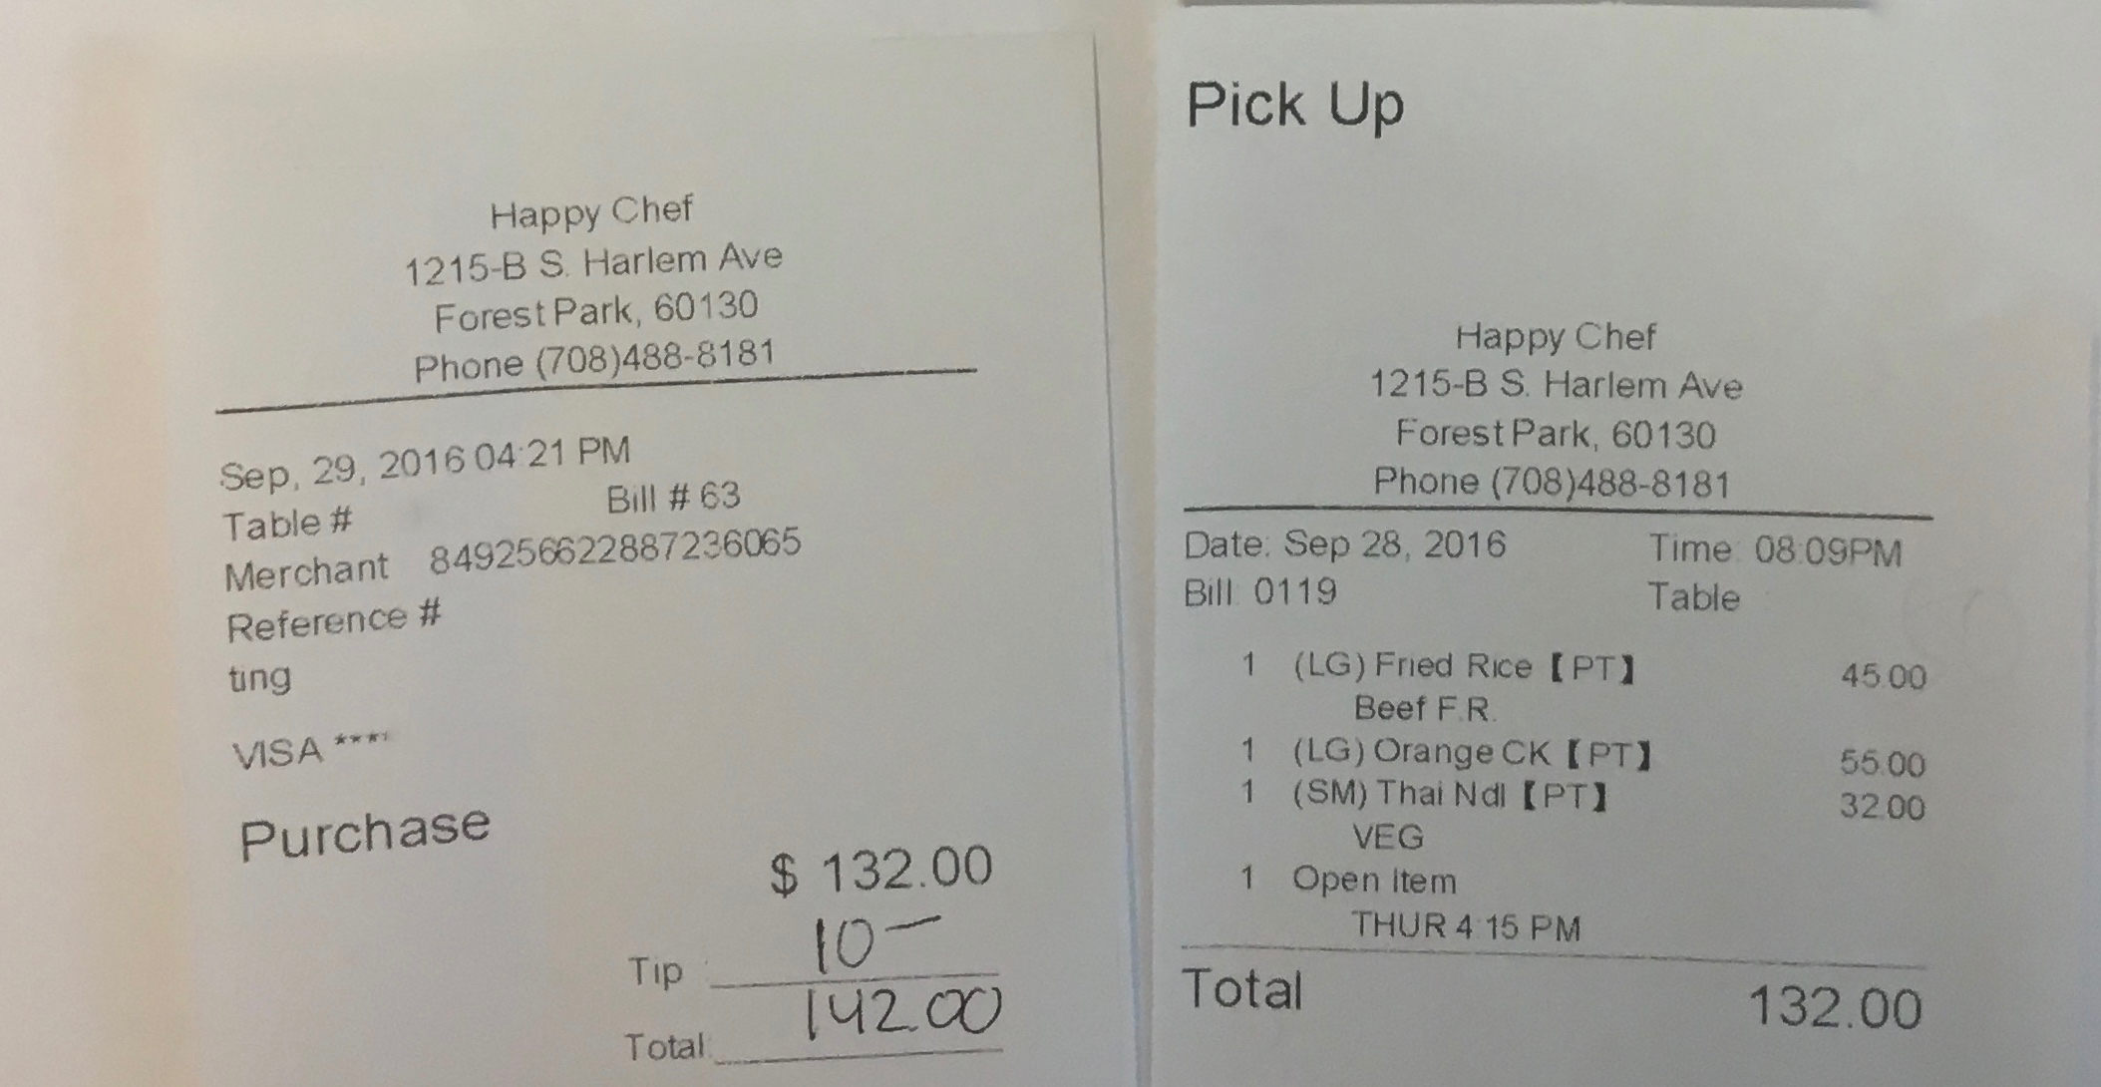

  - Secretary—Priya Patel
None

- Report from Class Presidents
  - M1 – Alyssa Varsanik
First anatomy exam today! They will be throwing a fall dance in the atrium (Nov 18) – there will be a DJ and photo booth! 90s themed and tickets are $5. Look out for email from your class social chair
  - M2 – Mitra Mossaddad
Start registration for STEP on NBME! Bring certification to be signed – Mitra has sent an email with more details.
Get your flu shot!
Friendsgiving – Nov 15. SWAG will be organizing it and will send out sign ups.
  - M3 – Patrick Kramer
Step 1 Stritch Groups are starting – look out for an email from your M3 leaders.
M3’s will also be hosting a course review for upcoming tests – they will have a powerpoint and do a quick review and then answer questions.
  - M4 – Lizzy Carroll
Submitted ERAS last month so people are going on interviews/away rotations!
GET YOUR FLU SHOTS – need that extra money for disorientation week.
Look out for email from Lizzy regarding upcoming events

- Reports from Stritch or University Committees
  - Medical school dean – Dean Brubaker is resigning, please look out for an email regarding this process
  - LCME Reaccreditation
Officials will be walking around campus so be aware and feel free to stop and chat with them!
  - CTRE access
Working on getting everyone access for the new building. It is being looked at by the Provost – we will keep you updated on progress.

- Reports from Student Organizations
  - LMSA – this Friday 6pm, we will be giving away free nachos and there will be a performance. This is to conclude Hispanic heritage month.
SAMSA – Diwali dinner, Oct 27 at 6:00pm. Look out for sign ups for that.
SAMSA conference Nov 5th – look out for an email, there will be free lunch.
SCIPEC – Vital signs night – nursing students will teach M1s how to use their new equipment, there will be pizza

- Reports from OSR Rep – Michelle Peterson and Saad Siddiqui
First conference beginning of November

- Student Wellness Advisory Group
  - None

- New or Unfinished Business
Motion was passed that all groups will be required to fundraise for themselves before they can request additional funding for a second time.

We are also talking about setting a cap for amount that can be requested per organization in order to keep it fair. Finally, we are considering placing a cap on the amount of money that can be requested this semester to ensure sufficient funding will be available next semester. If you have any ideas or concerns, feel free to email any of the MSU board members or submit an anonymous message through the MSU website (link at the end of these Minutes)

- Funding Requests
Net Remaining to be requested: $1,977.99
Total Requested today: $410

  - Hospital Medicine Interest Group - $85 (DENIED)
Money is for food
No majority motion to pass.
  - Oncology Interest Group - $50 (APPROVED)
Panel of physicians – money is for food for 50 people.
future fundraiser – beanies
  - SAMSA - $120 (APPROVED)
Diwali dinner, they have outside funding from Diversity Office and possibly Ministry. Last year they had to deny people since they did not have enough money and would love to include more people this year.
1 no - too much money requested
  - EMIG - $75 (APPROVED)
Panel of physicians – money is for food.
1 no - too much money requested
  - Ophthalmology Interest Group - $80 (APPROVED)
Resident panel in 2 weeks – residents will talk about experience
Money is for food

- Room for Improvement:
  - Input? Questions? Comments? Feel free to talk to us or submit your ideas anonymously through the following link:
    - https://goo.gl/forms/oSrghTSVDIOTIGa73

Thank you for taking the time to be here tonight!

