MSU Meeting Agenda: January 11th, 2017

- Presentation of minutes from December 6th, 2016
  - Corrections? None

- Report from the MSU Officers
  - President—Nadeem El-Kouri
    - Megan Troppito – director of marketing/communications
      - discuss current resources available to students for promoting events. (digital screens, university calendar, etc.) She will also discuss a student list-serve/communication channel and get your ideas on what students would use/like to facilitate that. (something akin to Stritch Savvy for students)
- shes on the 4th floor if anyone wants to stop by
- she will be sending an email on how you can submit your events to university calendar and electronic screens
- idea was suggested on the best way to include nursing and grad school students in the correspondences
- school has an official stritch school of medicine page you are welcome to check out
- any media relations must go through Megan – if you would also like to reach out to external sources please feel free to contact her
    - New Stritch Clothing at the Gym!
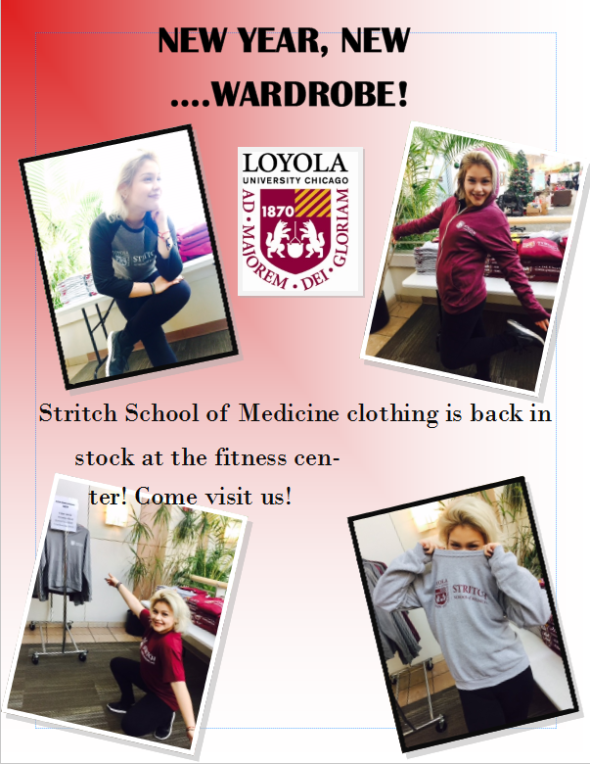
    - Student group hand off should happen by April 1st
Please come to Tomas or Nadeem with any questions
    - MSU Elections will take place soon!
Look out for an email from Priya in the first couple weeks of February and feel free to contact any of the MSU board members if you would like more information on our specific roles/duties
    - Blood donation opportunity severe shortage of blood nationwide of all blood types, especially O Negative.
Blood Drive hosted by the American Red Cross
Thursday, February 2nd
9:00 a.m. to 3:00 p.m.
Loyola Center for Fitness

- Student groups need to contact Tomas (and CC me) when exploring new fundraising items

  - Vice-President—Christina Small
    - Spring Formal Update
Ticket sales will start soon – look out for an email
Schoolwide Bulls game will be held Feb 14th (50% off) – 100 tickets will be available so be on the lookout!

  - Treasurer—Tara Funk
    - Presentation of the Budget
    - Groups expected to fundraise
    - Reminder to turn in all outstanding budget requests, within two weeks please
    - Tax Exemption
      - Will not reimburse you for spending money on taxes
      - Hand a tax free form to the institution that you are buying from
    - Don’t buy a gift card through a store. If you want to make a gift card purchase, it must go through Tomas and Lakeshore will purchase it and get it to you.
    - Must submit ITEMIZED receipts!! If you leave a tip, then I need both the charge receipt and the itemized receipt.
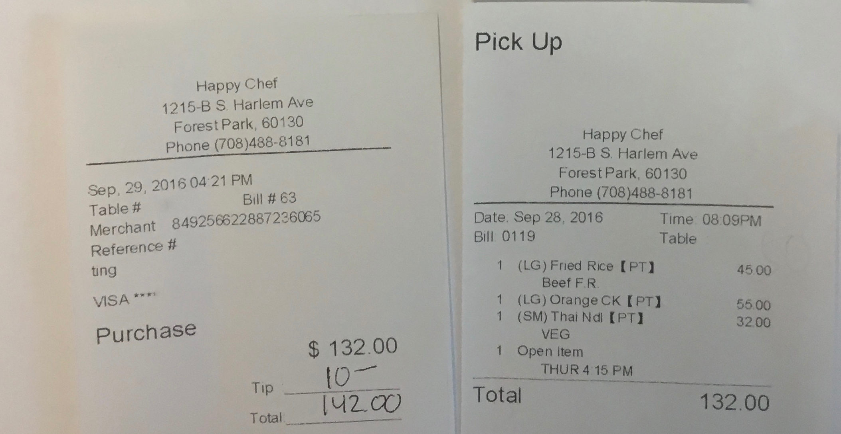

  - Secretary—Priya Patel

- Report from Class Presidents
  - M1 – Alyssa Varsanik
Created a facebook page for upcoming class of 2021!
  - M2 – Mitra Mossaddad
Please pay for UWorld ($315) by Thursday 5pm to ACE!
  - M3 – Patrick Kramer
Tomorrow is PCM3 day so parking will be tight!
M2/M3 social/mixer around end of January is in the works
  - M4 – Lizzy Carroll
Finish up interviewing soon,
Jan 15th – start ranking programs
Starting to plan for Match Day, Disorientation, M1/M4 mixer – so M4 be on the lookout for emails

- Reports from Stritch or University Committees
  - Medical School Dean
  - Student Affairs Director – hiring a new assistant to help M1/M2 with career choices and any advice, this will help Dean Sonntag focus on M3/M4.
Judy from Admissions will be retiring so please stop by and give her a hug! There will a retirement party coming up soon.
  - Food Services
Finish the review of proposals – we will not be going with Sodexo. Still in final stages of negotiation so changes will be coming up – tentative deadline is July 2017.

- Reports from Student Organizations
Integrative Medicine Group – There is a Chicago wide conference at Northwestern Feb 11 (open to all medical students) – (if you are intested, email or reach out to Brian Opferman M2)
Polish American Medical Society – community wide event to hear about medical school in Poland v. USA. 9:30am in Leishner Hall.
MIND - hosting the Region 4 PsychSIGN Conference at Stritch on Saturday, February 18. Ingrid Kiehl will be sending out an email regarding sign ups!

- Reports from OSR Rep – Michelle Peterson and Saad Siddiqui
Michelle- upcoming nomination of a physician for Humanism in Medicine Award – so if you have any recommendations, look out for nomination forms coming out soon. The 4 OSR reps for the individual classes will go through nominations and make a selection.
M1 OSR Rep – will gather all the info submitted by you guys, write essays and shadow the physician. So please submit as much information as you have to help facilitate the writing process!

- Student Wellness Advisory Group - Transition + DASH Meeting Thursday. See email from Alia.

- New or Unfinished Business
  - E-mailed Joseph Berg (@ jberg@loyolafitness.org) about bringing back hip hop, boxing, barre (preferably around 5pm or later)
    - “Boxing and Barre are special programs (additional fee based classes)that are still being offered. We are gathering all the surveys and will compile the data and revamp the schedule in February and March with some new classes.”
    - Parking situation will be addressed before Spring Break
    - Reimburse early – get a letter from bursar for landlord
  - Concern was raised regarding disbursing loans earlier next year since many students needed to pay rent etc and funds were not received until first week of January. Solutions are being discussed but in the interim – students may always go the Bursar office and request official documentation that shows proof to their landlord of their incoming loans for the future.
  - Concern was raised regarding parking issues in general as well as overnight/parking over breaks. Tomas will be getting back to us very soon and will definitely have a solution by Spring break.

- Funding Requests: NONE

- Room for Improvement:
  - Input? Questions? Comments? Feel free to talk to us or submit your ideas anonymously through the following link:
    - https://goo.gl/forms/oSrghTSVDIOTIGa73

The next meeting will be held on
Tuesday, February, 7th 2017

Thank you for taking the time to be here tonight!

