MSU Meeting Agenda: March 14th, 2017

- Presentation of minutes from February 6th, 2017
  - Corrections? None

- Report from the MSU Officers
  - President—Nadeem El-Kouri
    - Warm welcome to Handcut! (handcutfoods.com)
      - George Madzhirov - CEO and Founder
      - John Fuente - Director of Food and Beverage for Loyola HSD
Providing food in the cafeteria as well as where the starbucks is in Nursing school. Handcut is a small company from Chicago. Focused on quality ingredients and processing.
loyolahsd@handcutfoods.com - please send any questions to this address and George will get back to you asap.
John will be on site every single day – really want to promote ideas from student body and across all diverse backgrounds and incorporate it into the food
- They are looking into keeping some of the current staff if they are interested in stayin on
- Price are estimated to be in the same range for all the basic options (sandwiches, soup etc $6), with some of the nicer options being slightly more expensive (skirt steak etc $8)
- Official start date is May 1st – transition schedule with Sodexo in the works, probably have 1 week of limited menu while they switch over
    - Congratulations to the new MSU board!
      - President: Choumika Simonis
      - Vice President: David Grande
      - Treasurer: Christian Renz
      - Secretary: Brandon Karcher
    - Judy Porod Farewell Party
      - When: Thursday, March 23, 2017
      - Time: 2:30 – 5:00 pm
      - Where: Medical School Admissions Office, Room 200
    - Tomas Bolivar Farewell Party
      - When: Friday, March 24, 2017
      - Time: 12:00 – 2:00 pm
      - Where: Medical School Admissions Office, Room 200
    - Welcome to Viviana Martinez, the new Assistant Director of Student Affairs
    - Calendar issue SOLVED! (shout out to the real MVPs Michelle Peterson and Chris O’Hara)
We will be using a centralized google calendar (owned by MSU) that you can subscribe to. But each of the individual interest groups simply need to use their own group gmail to request access to the MSU calendar and then they can just add and edit their events on their own without any MSU Board middle man.
    - Ministry is considering bringing back Mass
Ministry originally cancelled mass due to poor attendance – considering bringing it back this Fall as long as they can get a regular attendance of at least 15 people. It is still very tentative and not guaranteed. But look out for future surveys/emails regarding your input. Having strong support from the student body would go a long way! This mass is open to everyone – including nursing students and the community so spread the word to garner interest.
    - Student group hand off should happen by April 1st
    - All student groups must register (See Student Leadership Handbook)
Please follow checklist before registering your group!
ALL GROUPS MUST REGISTER – regardless of whether you get MSU money, interest v. service group etc etc. ALL GROUPS MUST REGISTER IF YOU ARE AFFILIATED WITH ANY LOYOLA STUDENTS
    - Speaker(s) in the SAC
Working on getting this going!
    - Let us know if you’re considering fundraising, even if it’s an existing fundraiser!

  - Vice-President—Christina Small
    - Spring Formal is ALMOST HERE!
This Saturday 3/14 at Museum of Science and Industry !!!!! Great turnout of 350 people. There are 3 buses picking up in Forest Park (outside Doc Ryans), there is also free parking at the Museum if you are driving. There are no hard tickets, just come and tell your name! Make sure that you received a payment confirmation (email or bank statement) to ensure you actually have a ticket. Also come pick up your mug from Tomas!

  - Treasurer—Tara Funk
    - Presentation of the Budget
    - Groups expected to fundraise
    - Reminder to turn in all outstanding budget requests, within two weeks please
    - Tax Exemption
      - Will not reimburse you for spending money on taxes
      - Hand a tax free form to the institution that you are buying from
    - Don’t buy a gift card through a store. If you want to make a gift card purchase, it must go through Tomas and Lakeshore will purchase it and get it to you.
    - Must submit ITEMIZED receipts!! If you leave a tip, then I need both the charge receipt and the itemized receipt.
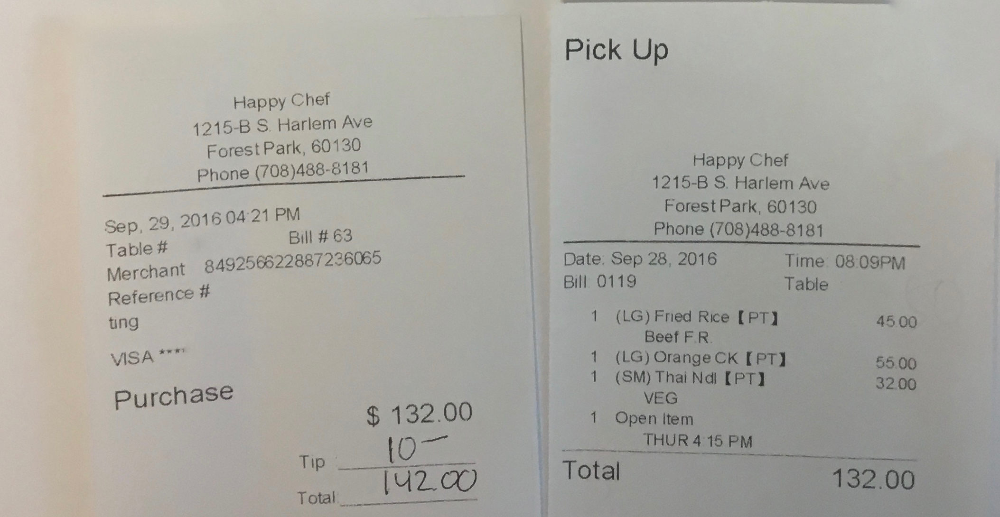

  - Secretary—Priya Patel
    - Upcoming elections for M2, M3, M4 Class boards will be held at the end of March.

- Report from Class Presidents
  - M1 – Alyssa Varsanik
No updates
  - M2 – Mitra Mossaddad
Step practice test this Saturday 3/14/17 – you received an email with room assignment, if you didn’t get one contact Josh Hopps
Please submit your favorite professor, facilitator and staff for Faculty Awards – check Mitra’s email for specifics
Please be respectful of the quiet study areas – especially for M2’s who will be preparing for Step.
  - M3 – Patrick Kramer
TGIF was a success at Bar Louie!
St. Baldricks is set for April – look out for an email from Patrick Kramer. PLEASE spread the word about this great opportunity to fundraise for pediatric cancer by shaving your head!
  - M4 – Lizzy Carroll
MATCH WEEK!!!!!!! Thank you to everyone else for being respectful especially in light of not knowing all the M4’s match outcomes (some happy, some sad)
Please avoid 2nd floor (atrium) on Friday to make room for M4’s and their family. But everyone else is encouraged to come and cheer M4’s from the 3rd and 4th floors!
20% of M4’s have NOT FILLED OUT AAMC QUESTIONNAIRE! So please do it ASAP or Lizzy will hunt you down!
The list of who matched and where is posted on admissions – so feel free to take a look and reach out to anyone if you have any questions. If their contact info is hard to find etc – just ask Lizzy and she will glad to redirect you!

- Reports from OSR Rep – Michelle Peterson and Saad Siddiqui
Thanks again to everyone for all the nominations! Saad is in the process of reading all submissions and writing up the finalized essay,

- Reports from Stritch or University Committees
  - Food Services – none

- Reports from Student Organizations
None

- Student Wellness Advisory Group
None

- New or Unfinished Business
None

- Funding Requests: Net remaining to be requested $2,187.47
  - Society of Women’s Health - Provider Panel - $100 APPROVED
Yearly event for this group – MD and community members (midwife etc) to provide a holistic perspective on the process. $100 for pizza for 50 people.

- Room for Improvement:
  - Input? Questions? Comments? Feel free to talk to us or submit your ideas anonymously through the following link:
    - https://goo.gl/forms/oSrghTSVDIOTIGa73

The next meeting will be held on
Tuesday, April, 4th 2017

Thank you for taking the time to be here tonight!

