**MSU Meeting Minutes**

**Tuesday, April 3rd, 2018**

1. **Report from the MSU Officers:**
   1. **President: Deena Kishawi**
      1. **By April 1st, student org transitions MUST have been completed online**
      2. **Student Leadership Summit on April 20, 2018 from 2-6:00pm:** All student organizations must send at least TWO executive board members to attend the Student Leadership Summit. Please see the e-mail from Student Life for specific details. Registration link for the Student Leadership Summit:<https://stritch.wufoo.com/forms/z1y597bu0vzd0xp/>
      3. **Second look is this week - Friday April 6th, 2018**
         1. If anyone wishes to sell items or post housing opportunities, please do so using the Facebook group **Stritch’s List**.
         2. Do not send out emails to class list-serves.
      4. As final exams approach, please be considerate of students studying on the 4th floor of SSOM, as it will be a designated quiet study space.
         1. Dedicated begins April 26th for M2s
      5. Attendance Policy for MSU
         1. Constitution states:
            1. The 1st and 2nd Year Classes must have at least 4 members or their proxies present.
            2. The 3rd and 4th Year Classes must have at least 1 member or their proxy present.
            3. Each organization must have at least 1 representative present.
            4. Each committee needs to have at least 1 member present.
            5. Each MSU chairperson must be present
         2. Every org needs to be adequately represented to ensure that every student gets heard information is communicated effectively and to secure funding from MSU
         3. If this is an issue for your org, please contact us
   2. **Vice-President: Rushad Marfatia** 
      1. **Spring Formal**
         1. Great turn out, special thanks to the previous MSU board for all their hard work
         2. Thoughts/suggestions for places next year?
      2. **Mixer in Fall**
         1. Thoughts/suggestions for places next year?
   3. **Treasurer: Lera Driver**
      1. Presentation of the Budget
      2. Place your request form, itemized receipt, and W-9 in LERA’S mailbox **(dePorres 347)** and email Lera with any questions (vdriver@luc.edu)
      3. Please use the new reimbursement request form that MSU will send out.
      4. $100 does not roll over to next year
         1. Many groups haven’t used it so this is still available
      5. Please submit final fund requests by **last day** of school
      6. Groups expected to fundraise
      7. Please turn in all outstanding budget requests within **two weeks**
      8. Tax Exemption
         1. Groups will not be reimbursed for spending money on taxes.Please provide a tax-free form to the institution from which you buy.
      9. Groups must submit **ITEMIZED** receipts! If you leave a tip, then Lera needs both the charge receipt and the itemized receipt.
      10. 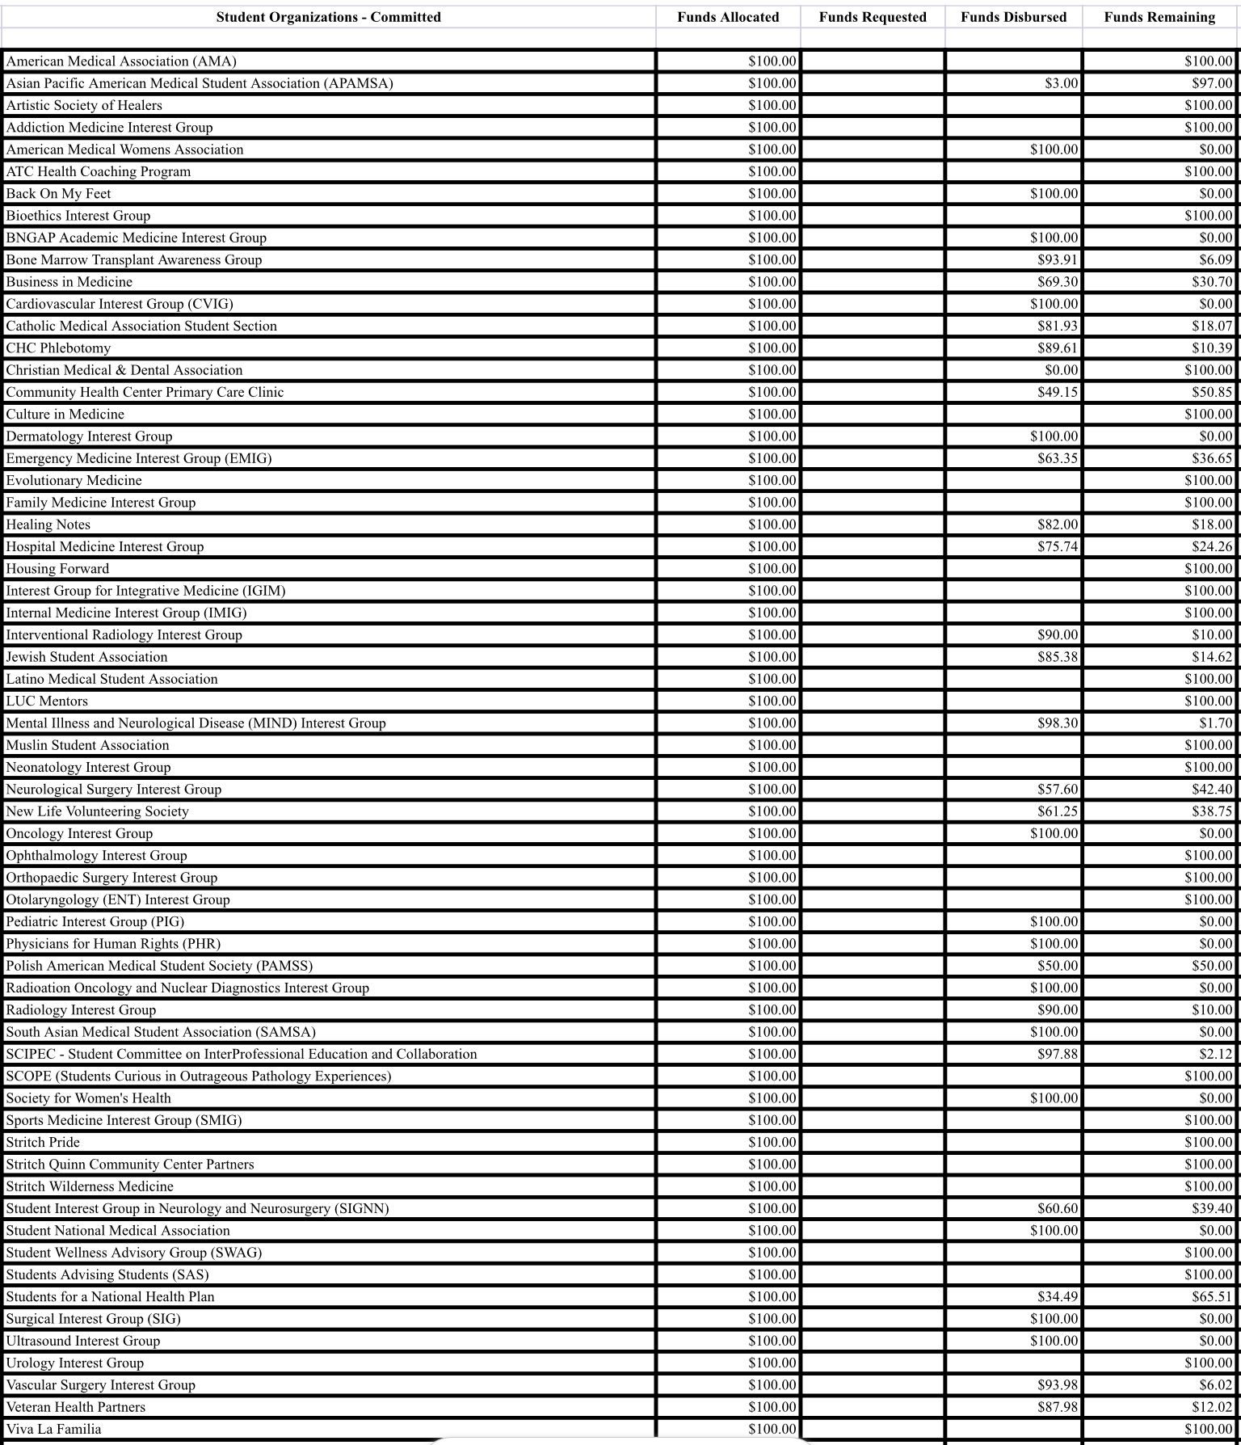
   4. **Secretary: Sara Imam**
      1. Class Board Election Results
      2. Open to any and all feedback
      3. Introduction of new class boards
      4. M2
         1. President: **Kevin Singh**
         2. Vice President: **Frank Leuzzi**
         3. Treasurer: **Sean Lamb**
         4. Secretary: **Juan Ariza**
         5. MSU Rep: **Kyle Lynch & Brendan Daly**
         6. Social Chairs: **Caitlin Smith & Zohaib Sherwani**
         7. OSR Rep: **Julie Mina**
      5. **M3**
         1. President: **Sahand Ghodrati**
         2. Vice-President: **Alyssa Varsanik**
         3. Treasurer: **Rhea Eubanks**
         4. Social Chairs: **Asha Mannancheril & Patsi Whiteside**
         5. MSU Reps: **Allison Fassett & Bianca Di Chiaro**
         6. OSR Rep: **Saad Siddiqui**
      6. **M4**
         1. President: **Mitra Mossaddad**
         2. Vice-President: **Angie Tsuei**
         3. Treasurer: **Nathan Pecoraro**
         4. Secretary: **Hajort Hansra**
         5. Social Chairs (2): **Kenneth Joseph & Christina Small**
         6. MSU Rep (2):  **Puja Gupta & Priya Patel**
         7. Alumni Relations Liasion (2): **Harika Reddy & Kevin Walsh**
      7. M3 Secretary Run-Off
         1. Email to be sent Wed, voting will occur Wed. - Fri., winner announced Friday, April 6th after 5pm
2. **Report from Class Presidents:**
   1. **M1 Aaron Perlow**
      1. Grateful for his experience with past board and looking forward to seeing greatness to come from the new board
   2. **M2 Sahand Ghodrati**
      1. April 26th is when “dedicated” begins
      2. Class dinner scheduled for April 26th at 5pm
      3. Fill out google form from Student Life about whereabouts during “dedicated”
   3. **M3 Mitra Mossaddad**
      1. Faculty awards taking place April 18th at 5pm in Atrium
      2. Helping out Belsy Garcia
         1. Please act now to support Belsy and her family as her father currently faces deportation from Georgia: <https://www.facebook.com/mark.g.kuczewski/posts/10215724332683665>
         2. Letter signed by 4000 in support of father, unfortunately proceedings are taking place and deportation is scheduled for today.
   4. **M4 Patrick Kramer**
      1. Living their best life
      2. **St. Baldrick’s event next Wed., April 11th 1-3pm** 
         1. Designed to show support for children with cancer and also financial support towards research on cancer
3. **Reports from OSR Reps: Saad Siddiqui and Julie Mina**
   1. Working on Humanism in Medicine nomination application for Dr. Boyd
   2. PLEASE SEND ANY AND ALL AMAZING EXPERIENCES w/Dr. Boyd by THIS Thursday!
      1. Email Julie: [jmina@luc.edu](mailto:jmina@luc.edu)
   3. Working on a 5 pg. essay on why she deserves the award on national platform, will be submitted by THIS Friday to AAMC
4. **Reports from Stritch University Committees: Dean Nakae**
   1. CLASS 2020:
      1. TB Testing & Drug testing: Quantiferon Gold is now required and included in student health. All orders will be in Student Health system, all you have to do is show up. Email with details will be sent soon
         1. Won’t be billed for this
         2. Will occur during M3 orientation
      2. Required to meet health deadline before start of M3
      3. Results need to be uploaded onto CastleBranch before orientation
   2. CLASS 2019:
      1. May also need to do TB & Quantiferon, details being worked out, look out for email soon
         1. Won’t be billed for this
         2. Will occur during M4 orientation
      2. Required to meet health deadline before start of M4
      3. Results need to be uploaded onto CastleBranch before orientation
   3. Parking is still having issues
      1. During big events, Valet is being purchased to avoid parking issues
   4. Locker/community/mailbox cleanup
      1. Lockers will now be assigned, but will have the same one during the entirety of your time at Stritch
      2. Should be done before dedicated
      3. More info to come from Student Life
5. **Reports from Student Organizations**
   1. None
6. **Student Wellness Advisory Group**
   1. Transitioning to new board, thankful for everyone’s support
7. **New or Unfinished Business**
8. **Funding Requests**
   1. **Society for Women’s Health funding $100 - Granted**
9. **Adjourn**
10. **Next Meeting**
    1. **May 1st at 6pm in SSOM 360**