**MSU Meeting Agenda**

**Tuesday, April 4, 2017**

1. Presentation of minutes from March 14, 2017
   1. Corrections – None
2. Report from the MSU Officers
   1. **President**- Choumika Simonis
      1. Brief introductions from the new board:
3. President: Choumika Simonis
4. Vice-President: David Grande
5. Treasurer: Christian Renz
6. Secretary: Brandon Karcher
   * 1. Congratulations to the M4 Class for matching! Enjoy the start of your new journey.
     2. Congratulations to the 2017-2018 Class Officers:

|  |  |  |
| --- | --- | --- |
| **M4 Class Board**    **President:**Patrick Kramer    **Vice-President:** Ryan Bonner    **Treasurer:**Sean Liebshcher    **Secretary:**Abby Otto    **Social Chairs (2):**Kevin Tuner and Terrance Feldheim    **MSU Rep (2):**Dan Grace and Richard Czuma    **Alumni Relations Liaison (2):**Ellen Swiontkowski and David Laczynski | **M3 Class Board**    **President:**Mitra Mossaddad    **Vice-President:** Angie Tsuei    **Treasurer:**Nathan Pecoraro    **Secretary:**Harjot Hansra    **Social Chairs (2):**Kenny Joseph and Christina Small    **MSU Rep (2):**Puja Gupta and Katie Lichter | **M2 Class Board**    **President:**Sahand Ghodrati    **Vice-President:** Chantel Smith    **Treasurer:**Rhea Eubanks    **Secretary:**Jamie Neelon    **Social Chairs (2):**Patsi Whiteside and Asha Mannancheril    **MSU Rep (2):**Allie Fassett and Bianca Di Chiaro |

* + 1. Castle Branch: Requirements need to be completed by the end of the school year. You will not be allowed to start the next academic year if they are incomplete. If your submission has been rejected multiple times or if you are having issues with your Titers, talk to Dean Nakae about the possibility of having a doctor’s note to use as a substitute.
    2. Wi-Fi Updates: The old networks (Loyola, SSOMWPA, & SSOMPUB) will be removed by the beginning of the fall semester. Students should transition to the new LUC network. Please note that the LUC guest account has limited accessibility. Login in with your UVID username and password. More info is below:

**“New Wireless Network for Students, Faculty and Staff**  
The new **“LUC”** wireless network is available. Any non-guest with a device that supports 802.1x, which includes laptop computers and mobile devices, should use this as their primary network to connect to Wi-Fi. The networks “Loyola”, “SSOMWPA”, and “SSOMPUB” will be removed prior to the start of the fall 2017 semester as part of this update.

Loyolans with devices that do not support 802.1x, including gaming consoles, streaming devices, and pre-2001 equipment, should use **“LUC-Devices”** to connect to Wi-Fi. This network requires a UVID and password, as well as the device MAC address. The network will only allow non-802.1x devices to be registered.”

* + 1. End of the Year Community Clean Up: Alia will send an e-mail with specific details in the next month regarding clearing out community lockers, mailboxes, and cubbies.
    2. The Celebration of Life for Dr. Schreckenberger event is on Friday, May 5th from 2:30pm-5:00pm in the CTRE. Please see the attached flyer for specific details. We encourage students to attend to celebrate the memory of a great educator and faculty member.
    3. 4th Floor Quiet Zone Reminder: There are signs in place to remind students that the 4th is a quiet study space. Please be considerate of M2’s as they prepare for their independent study time for STEP 1.
    4. Events for next year: St. Luke’s Day and/or Spring Formal
       1. School Survey: Please keep an eye out for a survey to gauge interest about a St. Luke’s Day Dance and Spring Formal. Last fall, in lieu of St. Luke’s, Alder after Dark was the main event. However, some students have expressed interest in bringing back the St. Luke’s Day Dance, as it is a Stritch tradition. We look forward to any feedback.
    5. Student Group Hand-Off Reminder:
       1. Groups need to create a Gmail account to gain access and post to MSU’s school-wide calendar. To request access, please email [ssom.msu@gmail.com](mailto:ssom.msu@gmail.com) with your information. [Here](https://calendar.google.com/calendar/embed?src=ssom.msu%40gmail.com&ctz=America/Chicago) is the link to the calendar.
       2. Calendar specifics: When posting event information, include the following – Title, Location, Time, & Brief Description (1-2 sentences).
       3. Event Cancellation Policy: DO NOT delete the event from the calendar. To cancel an event, please write CANCELLED in the title so students who RSVPed or want to attend are aware of the cancellation. It is the group’s responsibility to update their event information.
  1. **Vice-President**- David Grande
     1. Spring Formal: Thank you to Christina Small and the outgoing MSU board on a wonderful formal at the Museum of Science and Industry. Student feedback was positive. Again, keep an eye out for the survey about next year’s events. If you have any suggestions, please feel free to contact David Grande ([dgrande@luc.edu](mailto:dgrande@luc.edu)) or make suggestions using the MSU suggestion form.
  2. **Treasurer**- Christian Renz
     1. Presentation of the Budget

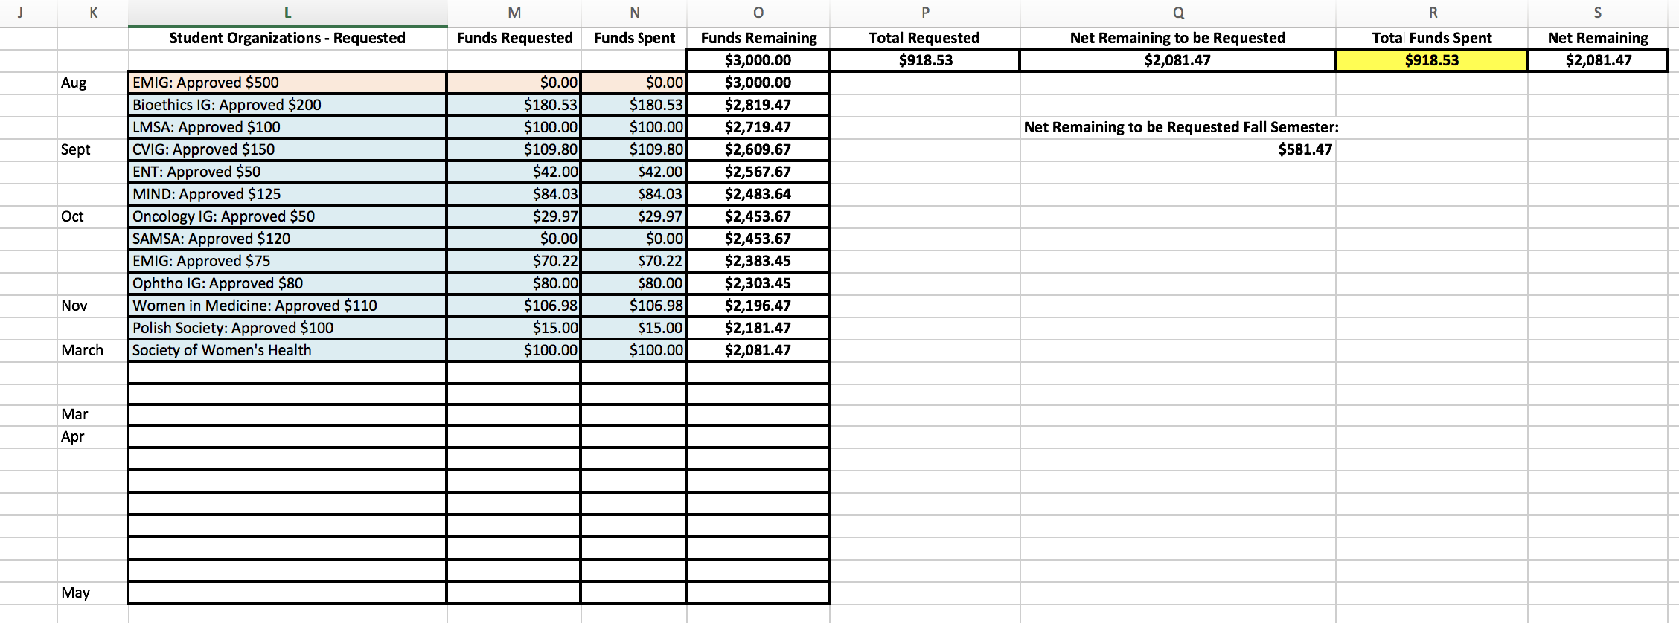

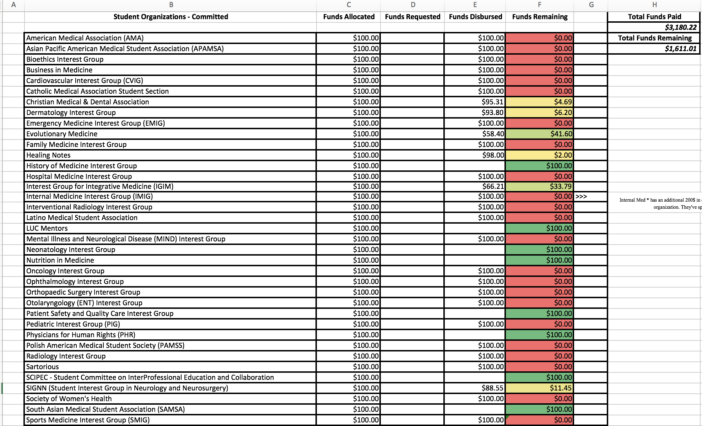

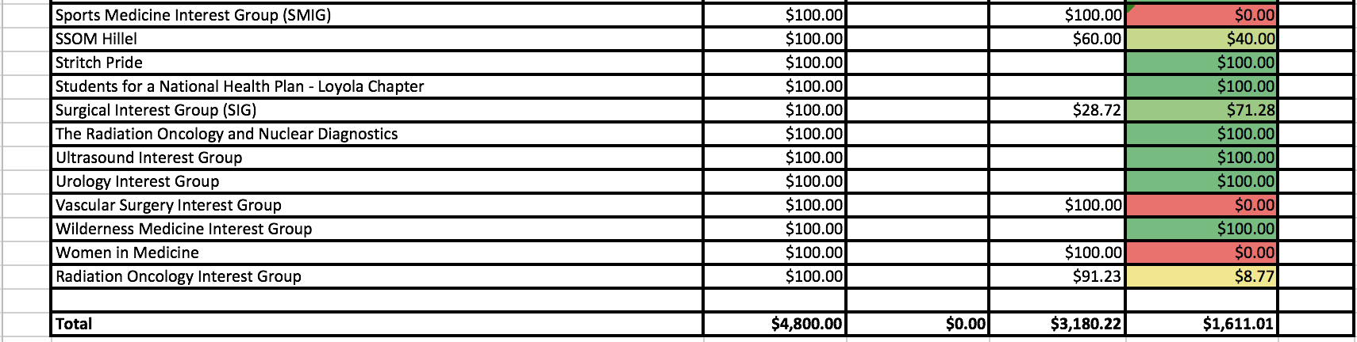

* + 1. Groups are expected to fundraise.
    2. Reminder: Submit all outstanding budget requests within two weeks.
    3. Tax Exemption
       1. Groups will not be reimbursed for spending money on taxes.
       2. Submit a tax free form to the institution from which you buy.
       3. Christian can provide you with the tax-exempt form.
    4. Do not buy a gift card through a store. If you want to make a gift card purchase, it must go through Alia. Then, Lakeshore will purchase it and deliver it to you.
    5. You must submit ITEMIZED receipts!! If you leave a tip, then Christian needs both the charge receipt and the itemized receipt. Please leave all your receipts for refunds in Christian’s mailbox, #406, in dePorres.

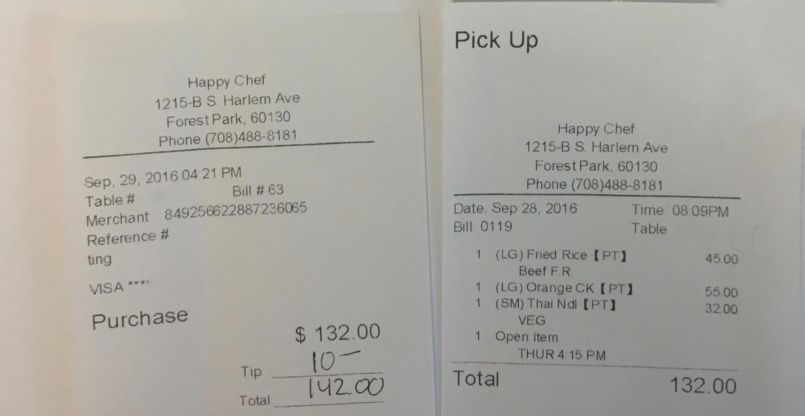

* 1. **Secretary**- Brandon Karcher
     1. Clarification on student organization representation at MSU meetings:

MSU board members cannot represent groups at meetings. However class board members are able to do so. A student can be the representative for multiple groups, but will still only get **one vote** per person (not per group). We encourage as many students to attend the MSU meetings. In addition, student groups should send one representative to each meeting, especially if the group wants to request funding.

* + 1. Class Board hand-offs: Clarification on the hand-off date will be provided and sent to the class presidents.
    2. Student Organization pages will be updated with the new officers soon. Student groups can request access from Brandon to customize their page.

1. Report from Class Presidents:
   1. **M1**- Alyssa Varsanik:

* M1 class had a difficult with week with the loss of their classmate and friend Amanda “Mandie” Wallinger. The class board had a memorial service on April 5th at 11am in the SAC followed by a pancake breakfast to come together as a community. Thank you to the upper classmen for their support during this hard time.
* M1/M4 Mixer was a great success at Cheesie’s in Wicker Park. It was a great way for M1’s to meet and congratulate students in the M4 class.
* Second Look reminder for Friday, April 7th. If you are still interested in helping, contact Catherine or Alia in admissions. Assignments have already been sent out for those who are helping. The M1 class will be hosting a Social with the prospective students that evening from 5pm to 7pm at Connolly’s Public House, 1109 South Blvd, Oak Park. All are welcomed to attend.
* M1’s have finished their faculty awards for the year and will finalize selections.
  1. **M2**- Mitra Mossaddad:
* The M2 class sends their condolences to the M1 class and offer any support to students in need.
* M2’s have finalized their faculty nominations and the board is reviewing them to announce a winner.
* The board is currently planning dedicated study period dinners and will send out more information shortly to the class.
  1. **M3**- Patrick Kramer:
* The login system for new observations has been changed. It is now in mylumen. Check your e-mail for more information.
* Course reviews will be finished by next month.
* M1/M3 shadowing should be finished before exams.
  1. **M4**- Lizzy Carroll: None

1. Reports from OSR Reps - Michelle Peterson and Saad Siddiqui: Dr. Robert Lichtenberg has been awarded the Loyola Humanism in Medicine Award. He received great comments especially from the M2 class, and he will be nominated for a national teaching award through the AAMC.
2. Reports from Stritch or University Committees – None
3. Reports from Student Organizations – None
4. Student Wellness Advisory Group:

* April 10th: Oral,Head and Neck Cancer Exams from 4pm-7pm at LCF.
* SWAG Fest is on April 20th from 11:30am to 1:30pm in the Atrium. The event will celebrate wellness, fitness and nutrition. There will be free massages from the LCF, fitness competitions, a granola bar, an organization fair, and raffle. Some items for the raffle include: free massages, free t-shirts, a gift card to Munch, wine night at Cycle Bar Fitness for 10 people. If you have any additional suggestions for event activities, please contact Kumuda Pradhan.

1. New or Unfinished Business:

* The 3rd Annual St. Baldrick’s Event is on April 18th after the M1 HD Exam. The event is to help raise funds for pediatric cancer research.
* Please spread information about the event and help the M3’s raise money for this noble cause.
* People are still needed for head shaving, as many of the M3’s are off-site and cannot attend to participate. Currently, five people are enrolled. If you want to raise money or join a team, please register [here](https://www.stbaldricks.org/events/mypage/11914/2017).
* If you do not want to shave your head, but would like to donate hair to Locks of Love, please contact Patrick Kramer.
* Potential participants of interest:
  + M1 Christian Perez, if the class raises $1000.
  + M2 Kenny Joseph, if the class raises $500.
  + M3 Ricky Czuma and Andrew McGurn, if the class raises $500.

1. Funding Requests – None.
2. Room for Improvements:
   1. Questions? Comments? Feel free to talk to us or submit your ideas **anonymously** [here](https://docs.google.com/forms/d/e/1FAIpQLSfvjqzcWoxr2lAHm0zkSN6crnQ7xd0sAb_38v6JkxRGbAjKPA/viewform?usp=sf_link).

The next meeting will be held on

Tuesday, May 2, 2017 at 6:00pm in SSOM 360

